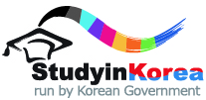
2021 KOREA-JAPAN JOINT HIGHER EDUACTION
STUDENT EXCHANGE PROGRAM
FORM 3 STATEMENT OF PURPOSE

(Please describe your goal of study or detailed study plan including future plan after study in Korea.)
※ Should be written in either Korean or English.
※ must be single spaced within TWO pages, with the font Times New Roman, size 11. (*11 points)

